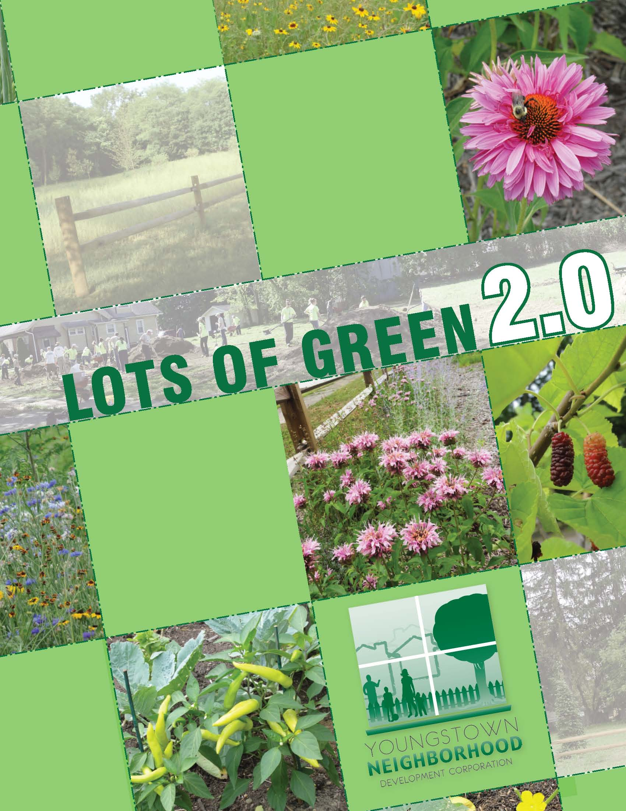

**About the Youngstown Neighborhood Development Corporation**

The Youngstown Neighborhood Development Corporation (YNDC) is a citywide multifaceted neighborhood development organization launched to catalyze strategic reinvestment in neighborhoods throughout the City of Youngstown. The mission of the organization is to improve the quality of life in Youngstown by building and encouraging investment in neighborhoods of choice for all.

The YNDC aims to accomplish its mission through a dual approach that includes: catalyzing strategic investments to rebuild market confidence in selected Youngstown neighborhoods with strong assets and creating broader partnerships to strengthen Youngstown’s community development capacity and the citywide infrastructure supporting neighborhood revitalization.

**The *Lots of Green* Program**

In response to the abundance of vacant land, the Youngstown Neighborhood Development Corporation (YNDC) developed the *Lots of Green* program, an innovative program to reactivate formerly derelict and blighted vacant land as a stabilizing asset for neighborhoods.

Over the past 4 years, the Lots of Green program has reactivated over 260 vacant lots (totaling over 35 acres) for multiple uses, established a 1.7 acre urban farm and training center, and presented comprehensive land use training programs. We present gardening and cooking classes at our urban farm on a regular basis – please contact our office for current class schedules.

**About *Lots of Green 2.0***

*Lots of Green 2.0* is a citywide competition to ignite vacant land reuse projects. The YNDC will select a limited number of innovative and impactful projects to support with financial and technical resources. Goals of the program include supporting vacant land reuse and positively impacting the stabilization of city neighborhoods. As this is a competitive process, there is no guarantee that projects will be funded. In 2013, we were able to award projects to approximately 1/3 of groups who turned in a completed application.

**Eligible Applicants**

Eligible applicants are located in the city of Youngstown and include groups of residents, neighborhood associations, businesses, non-profit organizations, and local faith-based organizations. All applicants should be committed to working with neighborhood groups and grassroots organizations to ensure the long-term success of projects.

**Eligible Project Sites**

All proposed project sites must:

* Be located within the Youngstown city limits.
* Be located in a visible area that will impact the stabilization of the neighborhood.
* Have community support from residents or businesses in close proximity to the project.

**Competition process**

This project competition is not a grant, and specific dollar amounts will not be awarded. The YNDC will work with the leadership group of the proposed project to refine the project idea. When a project plan is agreed upon, the YNDC will bid work to qualified local contractors, who will be paid by the YNDC. In general, the YNDC does not anticipate allocating more than $8,000 to any one project site. The YNDC will not be able to fund maintenance equipment or program costs such as salaries and stipends. Ongoing maintenance will be the responsibility of competition winners and their partners.

**Criteria for Selection**

Once applications are submitted, they will be reviewed by YNDC staff and the project review committee. Applications will be judged by the following criteria:

* Is the project or proposed phase of the project feasible during the grant timeline?
* Is the project location highly visible/impactful?
* Is the project likely to be maintained over the long term?
* Are the project goals clear?
* Does the project benefit the neighborhood, considering its current conditions?
* Could the project serve as a model that could be reproduced by others, especially at scale?
* Does the project have community support from the neighborhood?

**Competition Timeline**

* **July 2014 -** Training workshops are held at Youngstown public libraries or at YNDC. ***A representative from each group applying for project assistance must attend one of these workshops.*** Trainings should last about 1 hour. An RSVP to Liberty Merrill Senior Program Coordinator, via email at lmerrill@yndc.org is encouraged, but is not a prerequisite for workshop attendance. Please call if a representative of your group cannot attend a workshop, and we will try to accommodate you or schedule additional dates. Workshops are held on the following dates:
  + **Wednesday, July 9th, 5:30pm-6:30pm**, YNDC Demonstration Kitchen (822 Billingsgate Avenue, around the corner from 820 Canfield Road).
  + **Monday, July 14th, 6:30pm – 7:30pm,** Newport Library (3730 Market St., Youngstown, OH, 44507).
  + **Thursday, July 17th, 2:30pm – 3:30pm,** East Branch Library (430 Early Rd, Youngstown, OH 44505).
  + **Saturday, July 19th, 1:30pm-2:30pm,** Main Library (305 Wick Ave, Youngstown, OH 44503).
* **Friday, July 25th**: Application deadline, 5pm. No Exceptions.
* **Week of August 4th**: Winners notified by phone and project plans will be created.
* **Week of August 18th**: Winners will be publicly announced
* **Late Summer/Fall of 2014**: Work will be bid out to qualified contractors and completed

****Application should be mailed or hand-delivered to the YNDC offices, located at 820 Canfield Road, Youngstown Ohio, 44511. Applications must be received (not postmarked) in the office by 5pm on August 9th, 2013 – No Exceptions.****

**Application Cover Sheet**

**Title of Project: ____________________________________________________________________________________**

**Name of Organization or Group: ________________________________________________________________**

**Primary Contact Person**

**Name: _______________________________________________________________________________________**

**Street Address: ____________________________________________________________________________**

**Daytime Phone Number: ________________________________________________________________**

**Cell Phone Number: ______________________________________________________________________**

**Email Address: ____________________________________________________________________________**

**Secondary Contact Person**

**Name: _______________________________________________________________________________________**

**Street Address: ____________________________________________________________________________**

**Daytime Phone Number: ________________________________________________________________**

**Cell Phone Number: ______________________________________________________________________**

**Email Address: ____________________________________________________________________________**

**Program Application**

**Site Information**

Address or Parcel Number of Project Site (if no address is available, give adjacent addresses and describe site):

Why did your group/organization choose this site? Are there alternative sites within your neighborhood where this project could be implemented if your first choice is not feasible?

What is the ownership status of the property on which your proposed project sits? Has the owner been contacted or have reasonable attempts to do so been made?

If the property is abandoned, has the Mahoning County Land Bank (330.259.1040) been contacted about property acquisition?

**Project Information**

Provide a description of your project. What would you like to do?

How will your project benefit the community? What problem are you trying to solve with this project?

Who will be involved in the project, including any other organizations you will be collaborating with?

What long term maintenance will be needed for this project? Who will maintain it?

How will your group sustain the project in the long term and how will funds be acquired when needed (for water, seeds, mowing, gas, etc.)?

**Lots of Green 2.0 Community Support Petition**

**Project Name:_____________________________________________________**

By signing this petition, I agree that I understand and support the proposed

Lots of Green 2.0 vacant land reuse project in my neighborhood.



Please collect as many signatures as possible, especially from neighbors who own property directly adjacent to the proposed project site. Ten signatures will be considered a minimum number – applications with fewer than 10 signatures will not be reviewed. Additional copies of this sheet are available upon request, or another sheet of paper can be used. Please contact Liberty at YNDC with any questions.